EXP#1 Simulation Guidelines

**Experiment Admin:**  **Date:**

|  |  |  |  |  |
| --- | --- | --- | --- | --- |
| **Student ID No** | **Name and Surname** | **Points [for Admin]** | | |
| **QZ** | **Expr** | **T** |
|  |  |  |  |  |

In this experiment, you are asked to verify **Kirchhoff’s voltage** and **current laws** for DC and AC signals. To get familiar with the subject, you need to study the experiment document thoroughly from Lab manual.

On the course of the lecture, you will be asked to run your circuit simulation. Then, you need to pick up the required information from simulation to prepare your final report. To run simulation, you need a circuit simulation program (LTspice or a similar one). You can download **LTSpice** program from **www.analog.com** web site for free.

Simulations

**Required Component Names in LTSpice Library**

(1)DC Voltage Source: **cell**

(2)Sinusoidal Voltage Source: **signal**

(3)Resistor: **Res**

**SPICE Directive** for DC voltage or current: **.meas OP VR12 PARAM V(n1,n2)**

**SPICE Directive** for Effective Value of (Vn1-Vn2) voltage: **.meas TRAN VR1eff RMS V(n1,n2) FROM 3m TO 4m**

**A- Kirchhoff’s Voltage Law (KVL) Test**

**Measurement Circuit: Fig 1.3**

**Elements: R1 = 100 Ω, R2 = 47 Ω, R3 = 47 Ω; Vx(DC) = 5 V**

Run the following cicuit simulation for **DC analysis**.

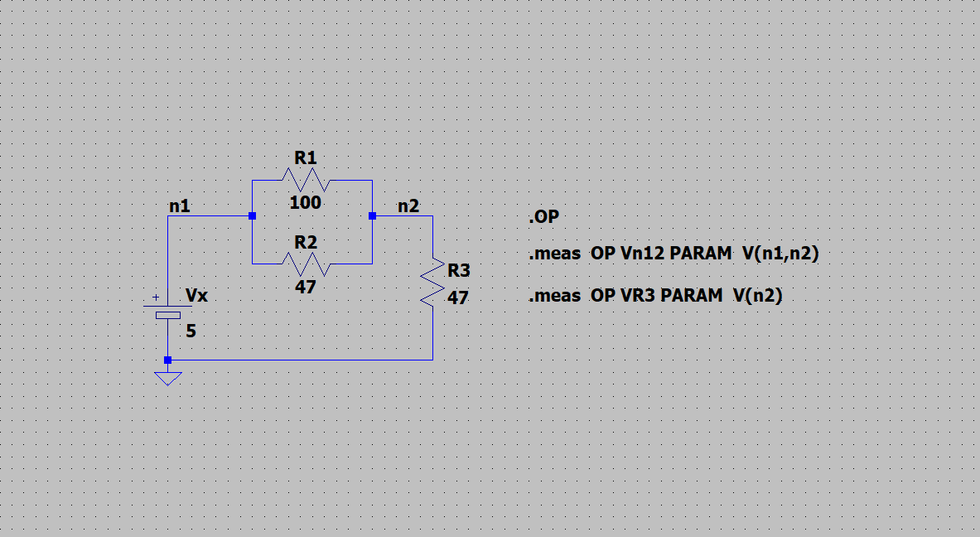

**Report requirements**

* From simulation results, fill out Table-A1 and verify KVL.

|  |  |  |  |
| --- | --- | --- | --- |
| **Table A1** | | | |
| **Vx [V]** | **VR1 [V]** | **VR3 [V]** | **Verify: VR1 + VR3 = Vx ?** |
|  |  |  |  |

**B- Kirchhoff’s Current Law (KCL) Test**

**Measurement Circuit: Fig 1.3**

**Elements: R1 = 100 Ω, R2 = 47 Ω, R3 = 47 Ω; Vx(DC) = 5 V**

Run the following cicuit simulation for **DC analysis**.

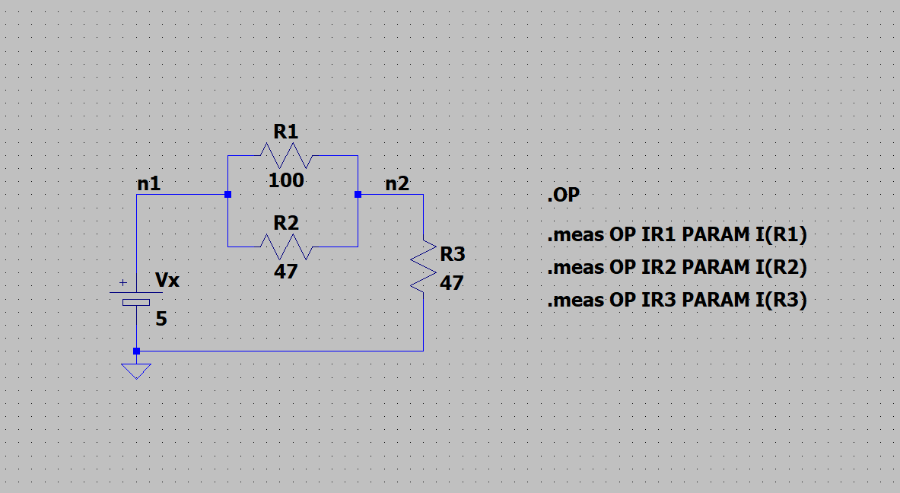

**Report requirements**

* From simulation results, fill out Table-B1

|  |  |  |  |
| --- | --- | --- | --- |
| **Table B1** | | | |
| **IR1 [mA]** | **IR2 [mA]** | **IR3 [mA]** | **Verify: I1 + I2 = IR3 ?** |
|  |  |  |  |

**C- AC Voltage and Current Measurement**

**Measurement Circuit: Fig 1.8**

**Circuit Elements:** R1 = 10 kΩ, R2 = 1 kΩ ; Vx(pp) : 10 V sinüzoidal waveform; f= 1kHz

Run the following cicuit simulation for **transient analysis**.

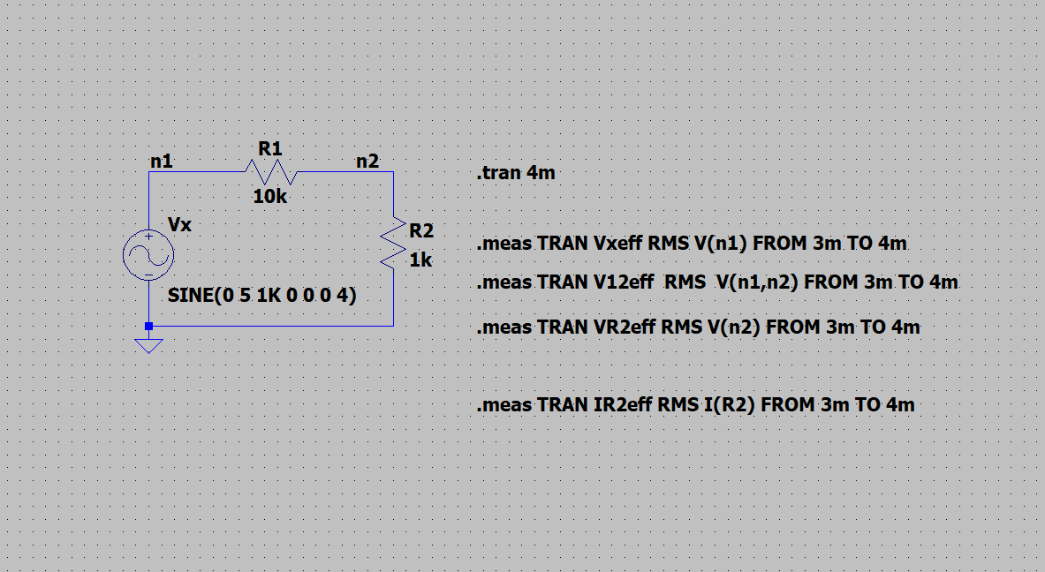

**Report requirements**

* From simulation results, fill out Table C1

|  |  |  |  |
| --- | --- | --- | --- |
| **Table C1** | | | |
| **Vx(Eff) [V]** | **VR1(Eff) [V]** | **VR2 (Eff) [V]** | **IR2 (Eff) [mA]** |
|  |  |  |  |

* Include Vx(t) waveform
* Include VR1(t) and VR2(t) waveforms

**Please report any error to** [**ozayan@itu.edu.tr**](mailto:ozayan@itu.edu.tr) **[AD, R2021.1]**